

**NAME: M. ALI KHAN & M. WALEED & MURTAZA KAZMI**

# SECTION: B

# ROLL NO: i210429 & i210438 & i210685

**COURSE: DATA BASE SYSTEMS**

**WORK: SEMESTER PROJECT REPORT**

**BATCH ID: BSCS-2021**

**Entity Relationship Diagram:**

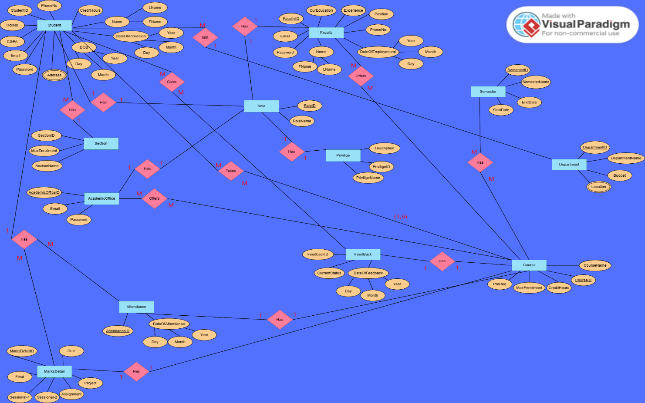

The Entity-Relationship Model explains all the necessary, minor and major relations between the tables and the tables themselves also according to the given scenario, requirements of the projects and are to the best of my knowledge. These tables and the relationships between them including the primary key and different types of attributes fulfil the demands of the Flex Management System as implemented by us with all the respective working real life features.

**Explanation:**

* The first part of the ERD is about:

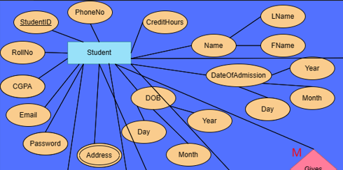

The Student Entity is a strong entity having its own primary key that has also been greatly used as a foreign key in many other tables because of its practical need. The Student table consists all the necessary attributes of a Real-life Student Entity, and all those that are listed in our University Flex Portal. Address has been used as a multi-valued attribute. There are some Composite attributes also such as DateOfAdmission which can have Day, Month, and Year also as taught to us during the semester. Rest all are the professional, needed and basic attributes of a Student which are then added to the Data Base also.

* The second part of the ERD is about:

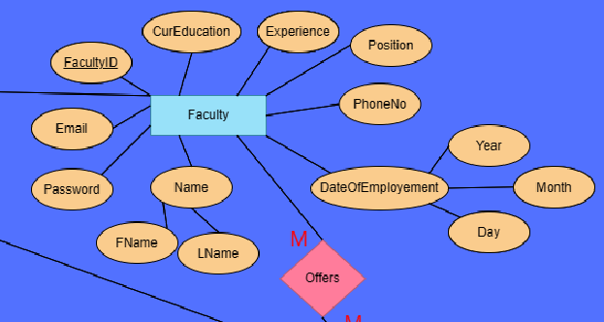

The faculty entity is also a real-life required entity having FacultyID as its own primary key which has also been used as a foreign key further in many tables. Rest all are the necessary attribute of a faculty member in a university or any educational institute.

* The third part of the ERD is about:

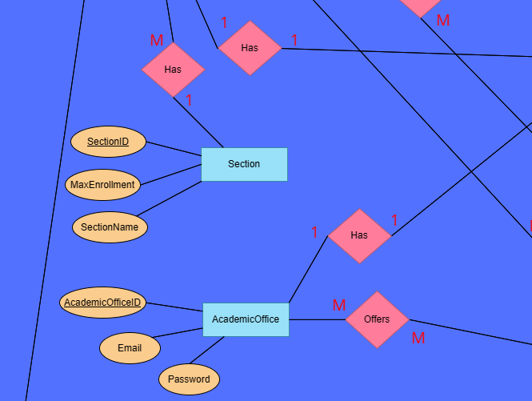

The Academic Office is also the Entity same as Faculty and Student who have the Righteous privileges to Login to the Flex Student Management System. It also has its Primary key and some very basic and necessary attributes.

The Section Entity is linked to the student in the relational model but here it has its own primary key and some attributes like MaxEnrollement (which is the maximum number of students that can be enrolled in a section) and the Name of the section as well.

* The fourth part of the ERD is:

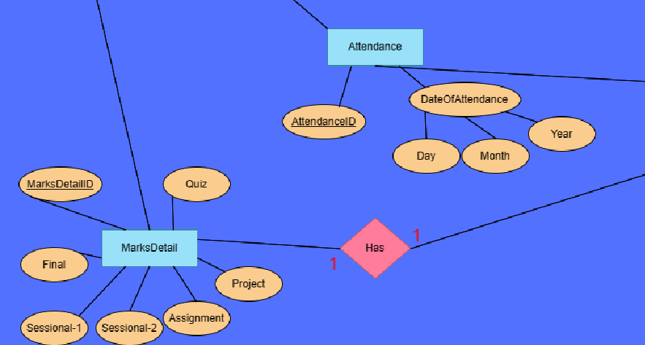

The MarksDetail Entity of this Data Base ERD is for adjusting the weightages of the course accessories by the faculty. So, that the faculty member can adjust the weightages of Assignments, Quizzes, Projects and others.

And similarly, the Attendance table has its primary key and a record element which showes that on which date the attendance was marked.

* The fifth part of the ERD is:

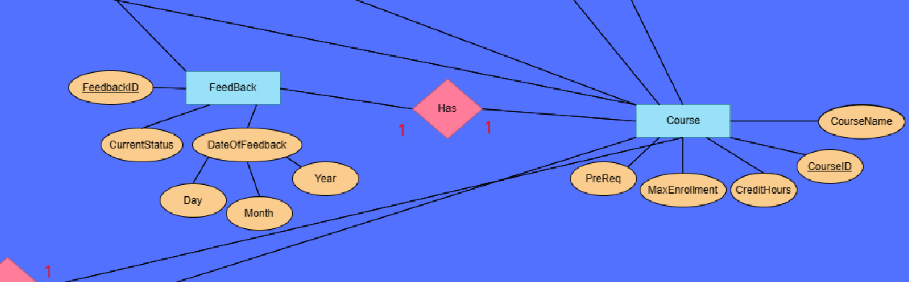

The FeedBack entity also has its own Primary key and all the other attributes will allows the Students to enter and submit the FeedBack of a particular course and then it’ll be saved into the Data Base.

* The sixth part of the ERD is:

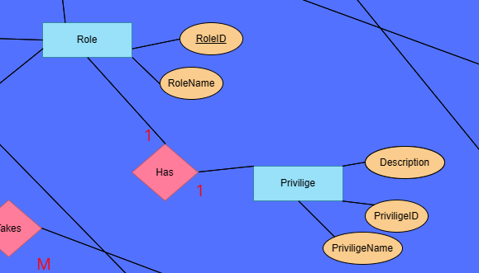This part holds a massive significance, the Role and Privilege keep the record of the type of roles that should have the particular types of privileges to enter the Flex Management System, this does the validation process also whether the particular user of the particular ID should be allowed to enter the Management System or not.

* The seventh part of the ERD is:

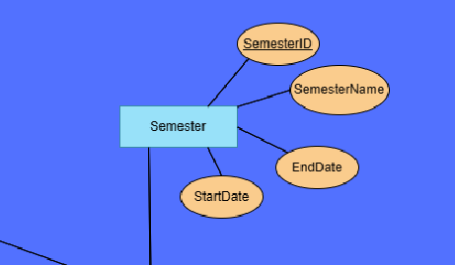

This Entity simply elaborates and hold the record of the Semester, it has its own primary key and Name of the semester also and the Start and End Date also.

**Relational Model:**

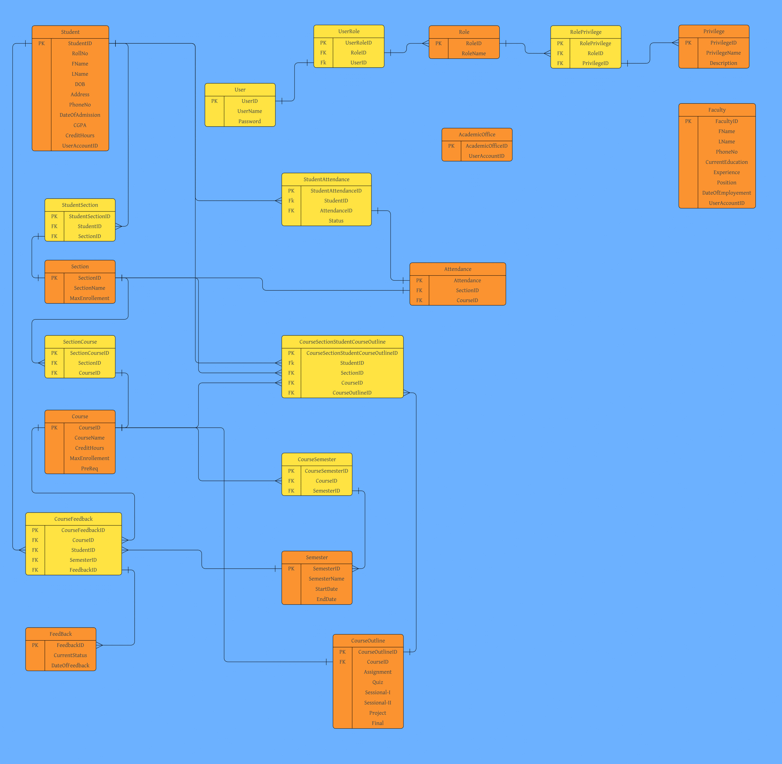

The Relational Model greatly explains the relationship between all the above tables in terms of 1-1 relation, 1-many relation, many-many relation and inheritance of foreign keys also which then fulfil the requirements of the desired products. It covers all the necessary tables and the relational tables also and what should be the nature of relation between them. Their exclusive explanation is given below:

* The first part of the Relational Model is:

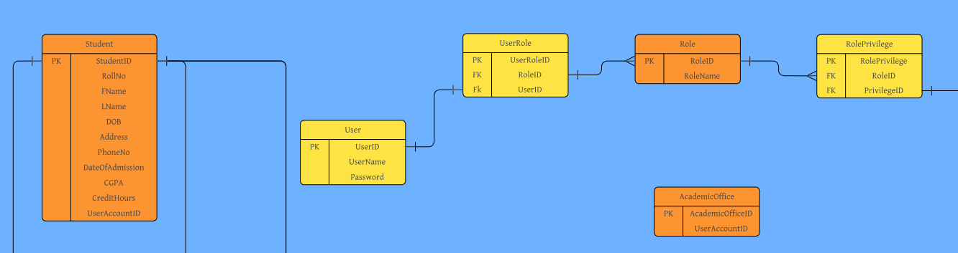

This part of the Relational Model explains the entity table of Student, which covers all its essential attributes and also shows the StudentID as its Primary key.

This respective image also shows the entity table of the AcademicOffice which also has its own primary key.

Now these table have one to one and one to many relation with the tables of User, UserRole, Role, Privileges, as these tables allow and let us know that which type of User has which kind of Privilege according to its respective Role.

* The second part of the Relational Model is:

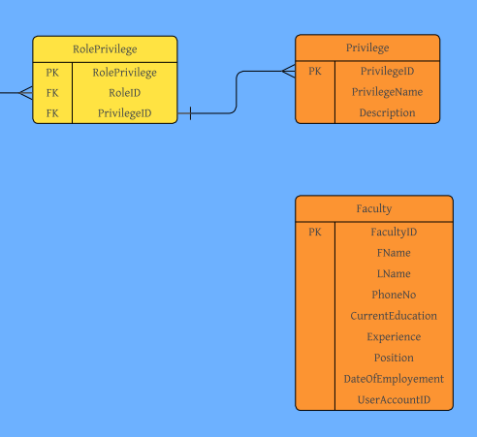

* This part of the relational model explains the entity table of Faulty having its own primary key and some necessary real-life attributes as well having the same kind of relation as Student and AcademicOffice had with the table of User, UserRole, Role, Privilege.
* The third part of the Relational Model is:

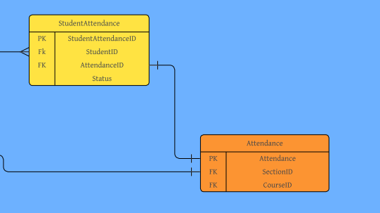

This part of the Relational model covers two entity tables of almost the same nature, Attendance, StudentAttendance having their own ID’s as primary keys and some foreign keys also. For example, the Attendance table takes SectionID and CourseID as the foreign keys. This step was done so that in the DBMS we can keep a check that the particular Attendance was of some Particular Course and of some Particular Section.

* The fourth part of the Relational Model is:

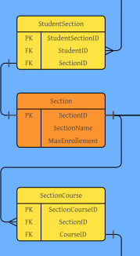

This part of the Relational model shows the entity table of Section, which shows that a particular student belongs to a particular section in the Data base.

The StudentSection table is a relational table between the entities of Student and Section having their foreign keys and its own primary key as well.

The SectionCourse table is also for the same purpose just to keep a track that the particular course was offered and is getting studied by some particular section of some particular department.

* The fifth part of the Relational Model is:

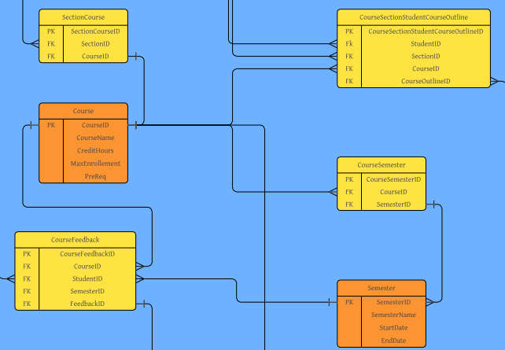

This part of the relational model explains the table of Course, having its own primary key and to keep the record of a particular course studied by the students which can then be related to all the necessary entity tables.

The Feedback and the CourseFeedback tables are also for the same reason, the CourseFeedback table is a relational table between the Course and the Feedback table having its own primary key and both the foreign keys of these tables so that we can relate that which particular feedback given by a particular student was of which particular course.

The Semester and CourseSemester tables are also of the same nature. It tells that which Course is being offered and being studied by which semester having its own primary key as all other tables are also having and some necessary foreign keys as well.

* The sixth part of the Relational Model is:

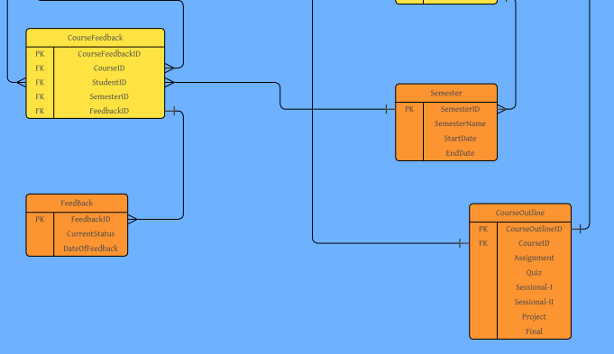

This snap shows the Feedback table which is already explained above.

The CourseOutline table here shows the attributes of Assignment, Quiz, Sessional-I, Sessional-II, Project and Final having its own primary key also. This table was made for the intend so that the faculty member can login and can adjust the weightages of these Semester elements according to their own choice or according to the decision of the respective course committee.

**Mappings:**

The mapping between all the above relational tables is done both upon the bases of the provided scenario description and on the independent flexible real-life requirements also.

For instances, as we skim the over all ERD and the Relational Model:

* 1 student will be studying in 1 section but 1 section will be having many (more than 1) students studying in them at one instance of time.
* Similarly, 1 student can give multiple feedbacks of multiple courses. But at one instance of time, 1 course will be having 1 feedback from 1 student.
* Also, 1 Role will be having many Privileges such as if we take the example of Faculty. The faculty member can offer course, can manage the Course Outline (weightages of the course elements), can manage attendance, can generate grades etc. These all are the privileges of faculty.
* Similarly, Student and AcademicOffice also have many such privileges. This means that 1 role has many (more than 1) privileges.
* Similarly, 1 student can study many (more than 1) courses at a time and can have different (many) attendances of all the particular courses.

These all are the approaches I have carried out to meet all the requirements that were expected from us to the best of knowledge and capabilities.